**DAILY ONLINE ACTIVITIES SUMMARY**

|  |  |  |  |  |  |  |  |  |
| --- | --- | --- | --- | --- | --- | --- | --- | --- |
| **Date:** | **28-05-2020** | | | | | **Name:** | **Apeksha Rane** | |
| **Sem & Sec** | **A** | | | | | **USN:** | **4AL17CS010** | |
| **Online Test Summary** | | | | | | | | |
| **Subject** | | **Operating System.** | | | | | | |
| **Max. Marks** | | **30** | | **Score** | | | **20** | |
| **Certification Course Summary** | | | | | | | | |
| **Course** | **INTRODUCTION TO CLOUD** | | | | | | | |
| **Certificate Provider** | | | COGNITIVE  CLASS | | **Duration** | | | 2hours |
| **Coding Challenges** | | | | | | | | |
| **Problem Statement:**1**.** Python program to find digital root of a number.  2. JAVA PROGRM-BALANCED BRAKET.  3. .write jsp code to display today’s date and time using expression tag  4, write jsp script to determine how many times the visitor has loaded the page  5. Given an array arr[] of size N and an integer K. The task is to find the last remaining element in the array after reducing the array. | | | | | | | | |
| **Status: Done** | | | | | | | | |
| **Uploaded the report in Github** | | | | | **YES** | | | |
| **If yes Repository name** | | | | | <https://github.com/Apeksha12appu/19-5-2020-online-coding-activity> | | | |
| **Uploaded the report in slack** | | | | | **YES** | | | |

Online Test Details:

Subject:-Operating System.

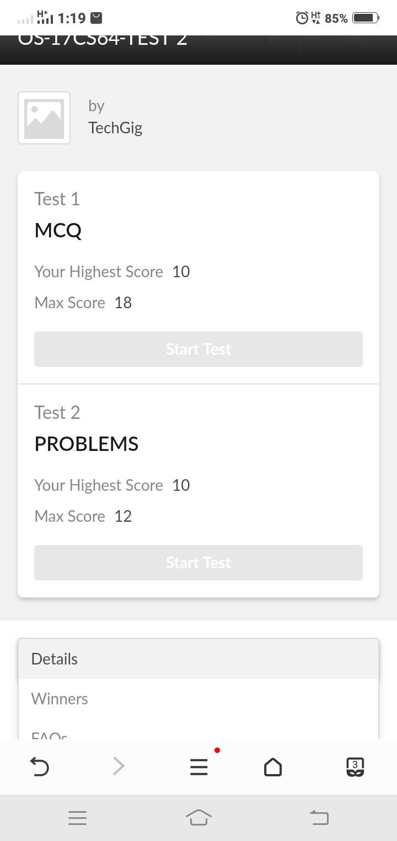

Certification Course Details:

**Introduction to Cloud:**

Today I have studied **:**

* Overview of cloud computing
* Definition and Essential Characteristics of cloud Computing
* History and Evolution of Cloud Computing
* Key Considerations for Cloud Computing
* Key Cloud Service providers and their services
* Hands-on lab: create a cloud account
* Attended module quiz exam

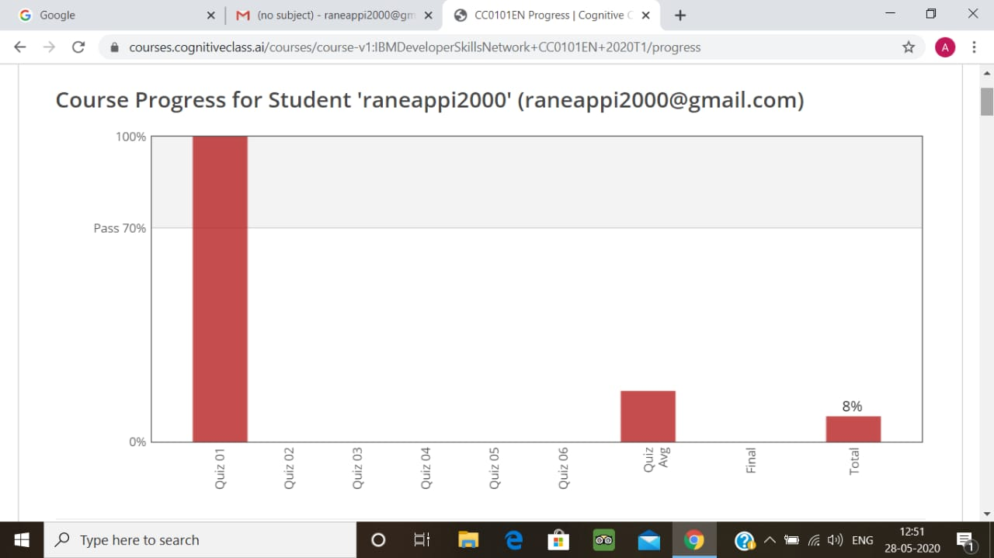

Coding Challenges Details:

1.Python program to find digital root of a number

Description:  
A digital root is the recursive sum of all the digits in a number. Given n, take the sum of the digits of n. If that value has more than one digit, continue reducing in this way until a single-digit number is produced. This is only applicable to the natural numbers.  
digit_root(0)= 0

digital_root(16)  
=> 1 + 6  
=> 7

digital_root(132189)  
=> 1 + 3 + 2 + 1 + 8 + 9  
=> 24 ...  
=> 2 + 4  
=> 6

def DigitalRoot(number):

addper = 0

while number >=10:

number = sum(int(digit)for digit in str(number))

addper +=1

#I highly recommend using return instead of print, but for testing purposes I used print

print(number)

DigitalRoot(132189)

**Output:**

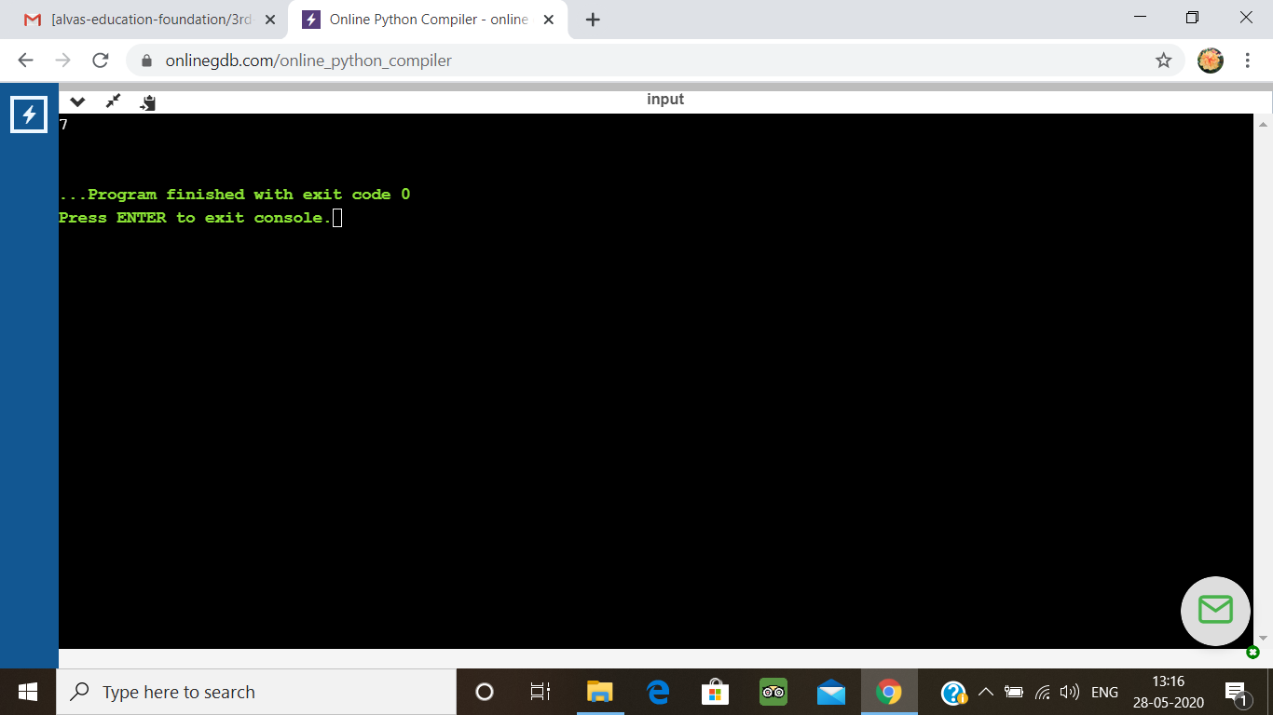

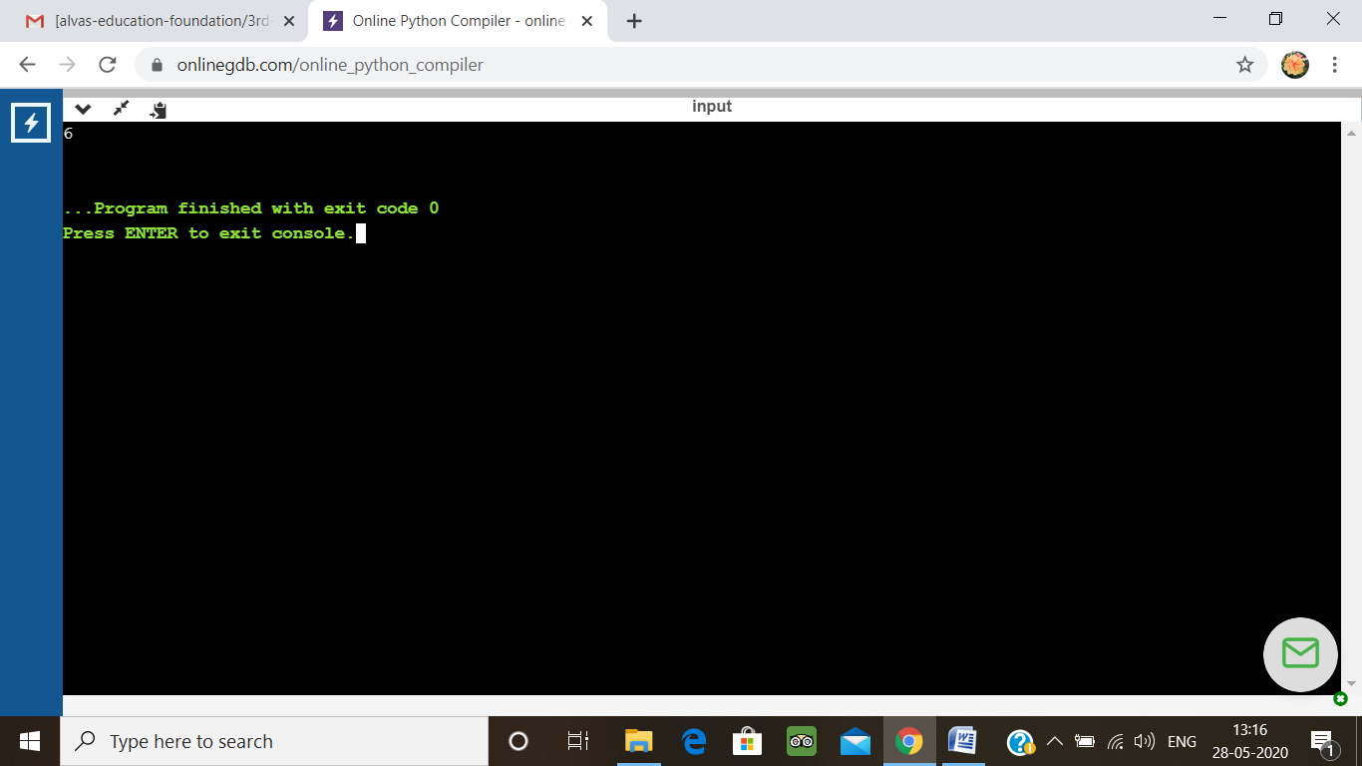

2. JAVA PROGRM-BALANCED BRAKET

Write a function that accepts a string consisting entiring of brackets ({}) and returns whether it is balanced. Every "opening" bracket must be followed by a closing bracket of the same type. There can also be nested brackets, which adhere to the same rule.  
f('()[]{}(([])){[()][]}') // true  
f('())[]{}') // false

import java.util.Stack;

public class Main {

public static void main(String[] args) {

System.out.println(is_parentheses_balanced("()[]{}(([])){[()][]}"));

}

public static boolean matchingPeer(char open , char close){

if ( open == '(' && close == ')'){

return true;

}

if ( open == '[' && close == ']'){

return true;

}

else{

return false;

}

}

public static boolean is_parentheses_balanced(String equation){

char[] c = equation.toCharArray();

Stack <Character> myStack= new Stack <Character> ();

for (int i = 0; i < c.length; i++){

if(c[i]=='(' || c[i] == '[' ){

myStack.push(c[i]);

}

else if (c[i]== ')' || c[i]==']'){

if(matchingPeer(myStack.peek(),c[i]) == true){

myStack.pop();

} else {

return false;

}

}

}

if(myStack.isEmpty()){

return true;

}

else {

return false;

}

}

}

**Output:**

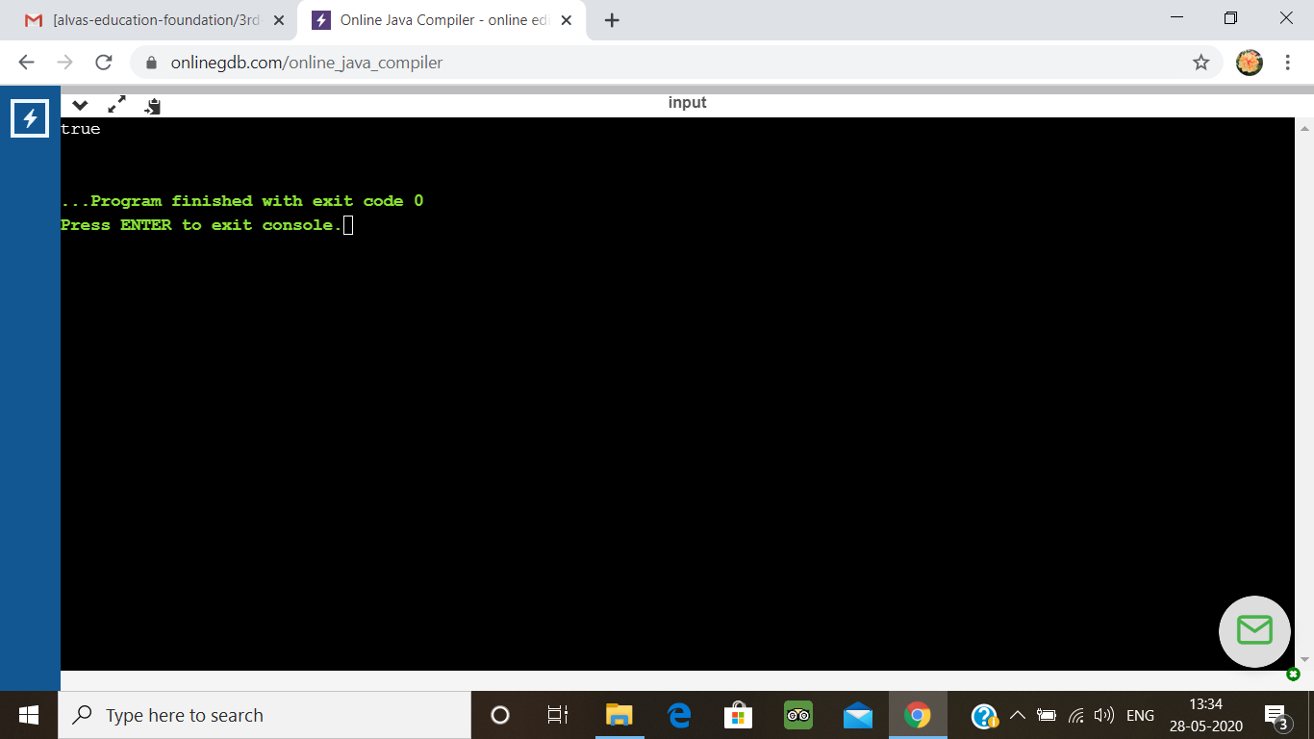

3.write jsp code to display today’s date and time using expression tag

<%@ page import = "java.io.*,java.util.*, javax.servlet.*" %>

<html>

<head>

<title>Display Current Date &amp; Time</title>

</head>

<body>

<center>

<h1>Display Current Date &amp; Time</h1>

</center>

<%

Date date = new Date();

out.print( "<h2 align = \"center\">" +date.toString()+"</h2>");

%>

</body>

</html>

**Output:**

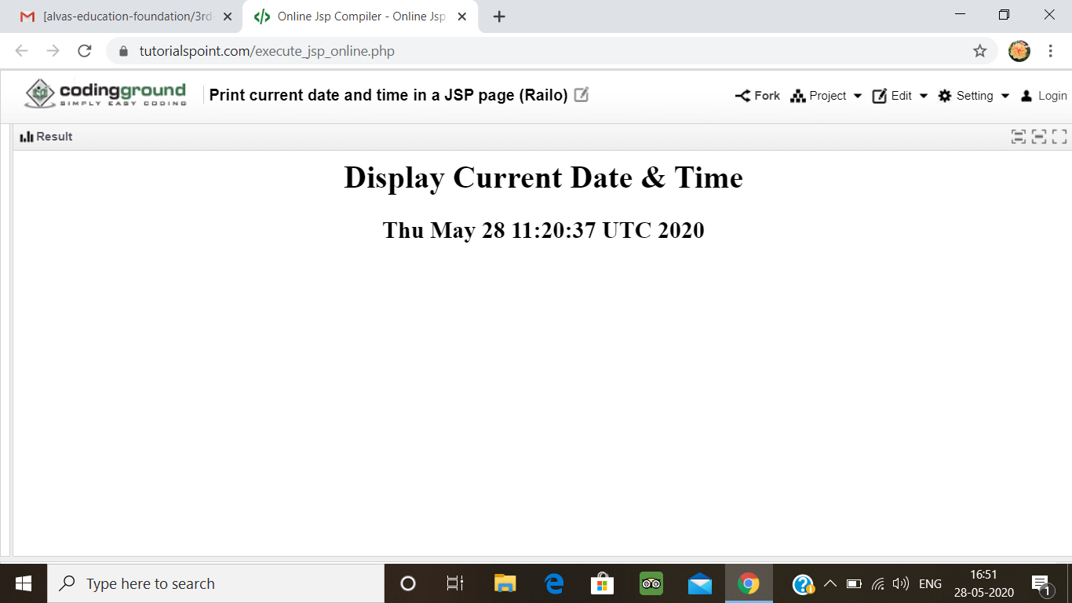

4. write jsp script to determine how many times the visitor has loaded the page

<%@ page import = "java.io.*,java.util.*" %>

<html>

<head>

<title>Application object in JSP</title>

</head>

<body>

<%

Integer hitsCount = (Integer)application.getAttribute("hitCounter");

if( hitsCount ==null || hitsCount == 0 ) {

/* First visit */

out.println("Welcome to my website!");

hitsCount = 1;

} else {

/* return visit */

out.println("Welcome back to my website!");

hitsCount += 1;

}

application.setAttribute("hitCounter", hitsCount);

%>

<center>

<p>Total number of visits: <%= hitsCount%></p>

</center>

</body>

</html>

**Output:**

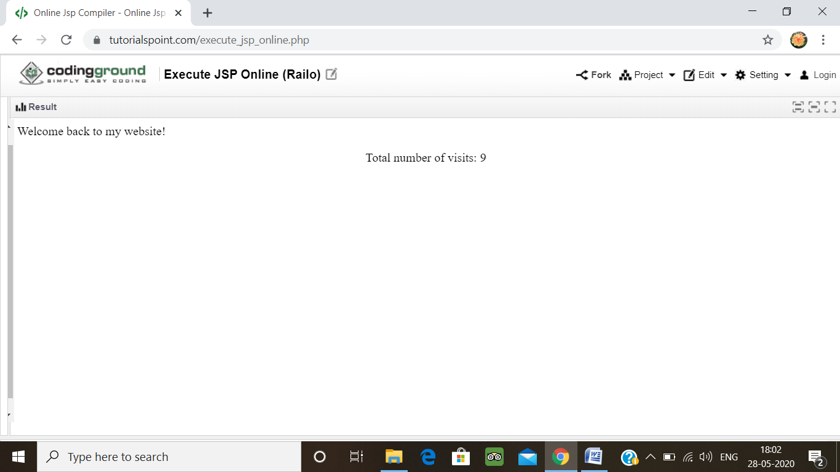

5.Given an array arr[] of size N and an integer K. The task is to find the last remaining element in the array after reducing the array.

The rules for reducing the array are:  
#The first and last element say X and Y are chosen and removed from the array arr[].  
#The values X and Y are added. Z = X + Y.  
#Insert the value of Z % K into the array arr[] at the position ((N/2) + 1)th position, where N denotes the current length of the array.  
Examples:

Input: N = 5, arr[] = {1, 2, 3, 4, 5}, K = 7  
Output: 1  
Explanation:  
The given array arr[] reduces as follows:  
{1, 2, 3, 4, 5} -> {2, 6, 3, 4}  
{2, 6, 3, 4} -> {6, 6, 3}  
{6, 6, 3} -> {2, 6}  
{2, 6} -> {1}  
The last element of A is 1.

#include <iostream>  
using namespace std;  
  
int find_value(int a[], int n, int k)  
{  
     
    int sum = 0;  
   
     
    for (int i = 0; i < n; i++) {  
        sum += a[i];  
    }  
   
    return sum % k;  
}  
   
  
int main()  
{  
    int n = 5, k = 7;  
    int a[] = { 1, 2, 3, 4, 5 };  
    cout << find_value(a, n, k);  
    return 0;  
}

**Output:**

